Analyze land cover of India for year 2009 and 2010 using Web App Builder in ArcGIS Online.
Tania Banerjee
GEO 662
Missouri State University

Introduction

Land cover
Land cover is the physical material at the surface of the earth. Land covers include grass, asphalt, trees, bare ground, water, etc. Earth cover is the expression used by ecologist Frederick Edward Clements that has its closest modern equivalent being vegetation.
Land cover change
Land-use and land-cover change (LULCC) is a general term for the human modification of Earth's terrestrial surface. Though humans have been modifying land to obtain food and other essentials for thousands of years, current rates, extents and intensities of LULCC are far greater than ever in history, driving unprecedented changes in ecosystems and environmental processes at local, regional and global scales.
Changes in land use and land cover date to prehistory and are the direct and indirect consequence of human actions to secure essential resources. This may first have occurred with the burning of areas to enhance the availability of wild game and accelerated dramatically with the birth of agriculture, resulting in the extensive clearing (deforestation) and management of Earth’s terrestrial surface that continues today. More recently, industrialization has encouraged the concentration of human populations within urban areas (urbanization) and the depopulation of rural areas, accompanied by the intensification of agriculture in the most productive lands and the abandonment of marginal lands. All of these causes and their consequences are observable simultaneously around the world today (Ellis, 2007).
Objective: To find the difference in the land cover of year 2009 and 2010 using different widgets in Web App builder in ArcGIS online.
Study Area
My study area is India. This landscape is within the biogeographic zone of the Deccan plateau in central and west to Himalayas in the north to Nilgiri Mountains in south and Bay of Bengal in East and is dominated by tropical dry deciduous and tropical moist deciduous forest (Champion and Seth 1968). The study areas are Kanha tiger reserve, Pench tiger reserve, Tadoba –Andheri tiger reserve, Sundarbans, Ranthambore tiger reserve and many more in India. According to the Wildlife Protection Society of India in 1991, the elevation ranges from 284 m to 950 m above main sea level. The total area of the forest is divided into the core area and buffer area.
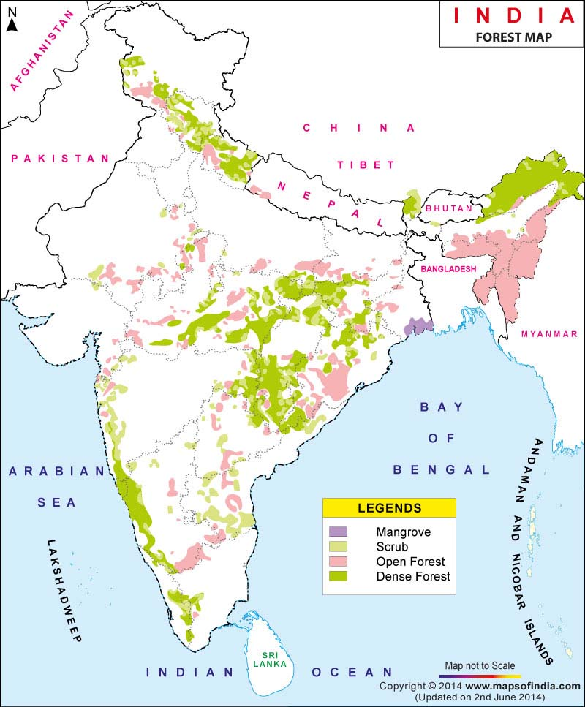
Source: www.mapsofindia.com
Data
Methods

Conclusion
LULCC has been a major area of research for many years. Many scholars and researchers have been working on the different land cover such as forests, agriculture, urban lands and so on. Using different classification techniques like fusion, band ratio, principle component analysis, supervised and unsupervised classification, the detection of land cover change has become easier. In India, forest land cover changes have significance because of the decline of the forests. Along with this, many wildlife species are also endangered such as tigers. Since it is an alarming situation, the Government of India has started making policies for forest and tiger preservation. Dense forest areas have been considered as protected areas. Out of all the factors causing LULCC, the conversion of forest land into agriculture is the important factor in causing maximum change. This change not only causes the forest to decline but also causes irreparable changes such as an increase in temperature of air and land, pollution, a decrease in rainfall and extinction of endangered species.

References
Remote Sensing. (n.d.) American Heritage® Dictionary of the English Language, Fifth Edition. (2011). Retrieved April 28, 2016, from http://www.thefreedictionary.com/Remote+sensing

Ellis, E. C., Kaplan, J. O., Fuller, D. Q., Vavrus, S., Goldewijk, K. K., & Verburg, P. H. (2013). Used planet: A global history. Proceedings of the National Academy of Sciences, 110(20), 7978-7985.

Kwarteng, A. Y., & Al-Ajmi, D. (1997). Satellite remote sensing applications in the State of Kuwait. Kuwait Institute for Scientific Research.

